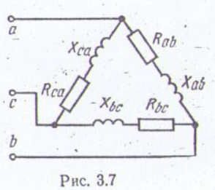
Дано:
U_{л} = 127 В
R_{ab} = 8 Oм
R_{bc} = 8 Oм
R_{ca} = 8 Oм Z = R + j (X_{L} – X_{c});
X_{ab} = 6 Oм Z_{a} = R_{a} - j X_{a};
X_{bc} = 6 Oм Z_{b} = R_{b} - j X_{b};
X_{ca} = 6 Oм Z_{c} = R_{c} + j X_{c};
I_{a},I_{b},I_{c}; Z =
P_{ab},P_{ab},P_{ca},P-?


